Kol simcha torah gazette
For parshas tzav 5784
Volume 8 Issue 29 (Whole #387) 20 Adar Sheni 5784/ March 30, 2023
Printed L’illuy nishmas Nechama bas R’ Noach, a”h

For a free subscription, please forward your request to keren18@juno.com
Past emails can be found on the website ShabbosStories.com under Brooklyn Torah Gazette

Closing Our Store on Shabbat Changed Our Lives
By Emily B.

Spurred by the Oct. 7 massacre, Jeff and Meredith Cohen closed their iconic Brooklyn liquor store on Shabbat for the first time in 83 years. They were shocked by the reaction.

“Jews Awakening” is a series of profiles about American Jews from various religious and cultural backgrounds who are strengthening their Jewish identity since October 7th.
It was a simple, yet meaningful, decision that changed the lives of Jeff and Meredith Cohen and their family. Born in Brooklyn to parents who owned a wine and liquor store, Jeff experienced a typical Jewish upbringing, with thrice weekly Hebrew School classes, a Bar Mitzvah at age 13, and Jewish holiday celebrations with his family. Over the years, he has forged close ties with the local Jewish community in Brooklyn through the family business which boasts an extensive selection of Kosher wines.

Until Recently Observing Shabbos
Was Not on His Radar
Jeff, 55, has always been proud of his Jewish heritage, but his religious observance has limitations. As he puts it, he doesn’t “pretend to be something he’s not.” Until recently, observing Shabbat was not on the radar.
Tops Liquor is something of an institution in Brooklyn’s Marine Park neighborhood. The red awning building has stood on Avenue U since 1941, and unlike so many surrounding buildings that have come and gone, the store has weathered the test of time largely intact throughout its 83-year history.
As Jeff grew older and started a family, he and his wife Meredith took on the family business and adapted to a demanding 7-day work schedule. The collective efforts of Jeff, Meredith, and Jeff’s parents helped expand the store’s footprint from 500 square feet to 10,000.
With success came more time away from their children and parents. The demands of a grueling schedule began to bump up against family priorities, leaving the couple yearning for greater balance and meaning in their lives. It was Meredith who initially proposed the idea of closing the store on Shabbat.

Relegating Their Dream to the Backburner
At first, the plan seemed daunting, even unachievable. There were practical considerations to worry about – the business could take a hit financially, and it wasn’t clear how customers would respond to the change. Feelings of imposter syndrome soon crept in; how could someone who had never observed Shabbat start to perform such a significant act so late in life? Motivated, yet scared to act, the couple continued to dream about the idea for some time, relegating it to the backburner with other bucket list items.
But then the October 7th massacre happened, and the attacks became a motivating factor that pushed them to finally take action.
The morning of October 7th hit Jeff deeply. “I woke up and I was crushed. It hurt me a lot,” he recalls. As news of the attack poured in, Jeff felt a mix of emotions – intense pride and love for the Jewish community tempered by anger at the events which had transpired. He was touched to see shows of unity among fellow Jews in the aftermath of the attacks, including his own customers.
“Where else would people run to a country that’s at war?” he says. “I’ve never seen my customers run back to Israel so quickly - four, even five times.”

After October 7th, Tops Liquor ran a promotion on Israeli wines, offering an 18% sale to raise money for pro-Israel organizations. The attacks had a subliminal effect on Jeff and Meredith, which accelerated their desire to strengthened their Jewish connection. “It didn’t make us make the decision but when we look back on it, it definitely helped make us more comfortable… it made it feel more-right.” It was the catalyst they needed to take the plunge. “This was always in the making I just never knew when we were going to technically pull the trigger and say, ‘Ok let’s do this and see what happens.’”
This past January, Tops Liquor closed its doors on Shabbat for the first time in 83 years. The story was quickly picked up in an online, and what followed was an outpouring of support so significant that Jeff and Meredith say they are still processing it.

First came visits from customers who showed up by the dozens to shake Jeff’s hand and cheer on his decision, using words like “inspiring” and “incredible.” Then, when the story broke, calls began to flood in from every corner of the world.
“I’m getting calls from every rabbi all over the country; calls from Europe, calls from the Middle East, we had a guy call the other day from Russia and tell me I inspired him to start wearing Tefillin… The other day my phone was ringing so much that my wife had to screen the calls. It was just people wanting to say ‘I love you’ and ‘you inspire me’ and ‘you made me cry.’”

More Confident from Their Personal Fulfillment
To Jeff and Meredith, it was proof positive that they had made the right decision, and the personal fulfillment they experienced gave them even more confidence.
“These last six weeks have been possibly the best six weeks of my life from so many different angles,” Jeff says. “I’ve achieved peace of mind being able to be home with my wife and daughter and dad.”
The chance to relax among family coupled with a newfound sense of meaning reinvigorated the couple from burnout. “We wake up now on Sunday and we can’t wait to go to work because what’s going on at my store is incredible. The weeks are flying by,” Jeff says. He now recognizes that observing Shabbat is “one of the best things you can do to honor G-d,” but he has been caught off guard by how an organic decision rooted in self-improvement led to such a frenzy.
“All we did was make a conscious decision that we wanted to live a better life and somehow what spiraled out of this is something that I’ve never seen before - the support, the love, the affection has been incredible.”

Adjusting to the Newfound Attention
It has taken Jeff some time to adjust to the newfound attention and come to terms with the impact he is having on the wider Jewish community. He sees it as a Divine intervention. “Maybe this was all meant to be. Maybe G-d had a message for me.”
If Shabbat is the heart of Jeff and Meredith’s spiritual renewal, then the store on Avenue U has become its soul. It is here that Jeff has started putting on tefillin every day, side by side with customers and bringing together Jews from all different backgrounds.
“When I see my customers come out and align themselves together, whether they’re Ashkenazi, Sephardic, Syrian, non-religious - they’re all one people. It’s pretty inspiring,” he says. “I think Hamas messed with the wrong people.”
Jeff and Meredith's simple motivation to live a better life has had an outsized impact that continues to pay dividends for themselves and their community. For the couple, it’s a reminder of the good things that can come from engaging with Jewish community, putting oneself first, and - for Jeff, listening to your wife. “With everything going on in the world and especially October 7th, this makes me so positive that we made the best choice we could. I’ve never been more proud to be a Jew.”

Reprinted from the current website of aish.com.
Rav Avigdor Miller on
What is Expected of
A “Simple” Man

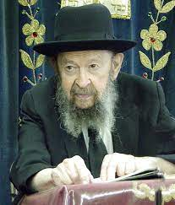

QUESTION: Rabbi, you said that when we leave this world we’ll be taken to task for not studying the Maaseh Merkavah. How can a plain man achieve that?
ANSWER: The question is that it was mentioned here that a man will be brought to judgment and he’ll be asked, “Did you study Maaseh Merkavah, the secret knowledge, the secret wisdom?” So, the question is: How can an ordinary person be held responsible for that?
So, the question I can ask is this: How can an ordinary person repair television sets? Some of these sets are very complicated mechanisms. But when a man applies himself, every man discovers that he has big capabilities in various fields.
I know that there are people here who have skills that would make me appear like a baby compared to them. So, the question is: How do they learn it? The answer is: When you apply yourself, you learn it.
Every Jew is expected to apply himself also to the important task of mastering the principles of Torah. In accordance to his opportunities, that’s how responsible he is. If a man had opportunities and he could have studied Maaseh Merkavah, he’s held responsible for not doing that.
Now, if he was a yasom, he was an orphan, he had no teachers, he lived in wartime, he was buffeted by circumstances, then he’s not held responsible for that. But responsibility has no end because the capabilities of human beings has no end.
TAPE # 22 (April 1973)

Reprinted from the Parshas Tzav 5784 email of Toras Avigdor. Transcribed from Tape #R-34 (March 1972).

Rabbi Berel Wein on
Parshat Tzav 5784

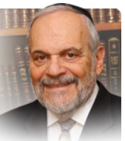

The entire thrust of Torah life lies in the word tzav which informs us as the title of the parsha of this week. Tzav means command, order, instruct. It allows little leeway for individual creativity in the performance of ritual and commandments.
The values of Torah life come with an instruction manual. And just as the wonderful gadgets of technology in our lives require adherence to the manual that accompanies each device, in order for it to operate effectively, so too the Torah in the spiritual realm of Judaism requires adherence to specific instructions.

It is not for naught that any and all of the blessings that were composed by the rabbis to be recited before the performance of a mitzvah contains the word v’tzivanu – and He has commanded us, for the word mitzvah itself, which we usually translate in terms of being a good deed, literally means something which has been commanded.

It is this recognition of being commanded, of following the instruction manual of the Torah in a committed and punctilious fashion that defines Judaism throughout the ages. In today’s world there are many who seek to “improve” upon the Torah. They have written a new and everchanging manual of instructions using such sweet- sounding terms as “relevant” “progressive” “attractive” to describe prayer services, Torah commandments and Jewish values.

The fault line in Jewish life today remains, as it always has been, this acceptance or rejection of the concept of v’tzivanu. But Jewish history teaches us that none of this tinkering with that concept survives the passage of time and the ever-changing mores of human society. It is only the old instructional manual that still stands and preserves us after all else has passed from the scene.

The concept of v’tzivanu rubs us the wrong way. We are by nature rebellious against authority imposed upon us by others. From infancy onward we demand to do it all by ourselves, when and how we wish. We can sense what the rabbis meant when they said that the people of Israel accepted the Torah at Mount Sinai and they felt that the mountain hung over their heads as a terrible and forced burden.

Here they were going to be commanded to do things in certain exact ways, to make the Torah’s values supreme over their own personal desires, logic and way of life. But they were warned then that abandoning the Torah and not following the instructional manual would bring personal and national problems, tragedies, defections and harsh judgments.

The mountain still hangs over our heads as we are witness to this fact in so many facets of our lives. So again, we are brought full circle to the idea of tzav and v’tzivanu. The concept of tzav as promulgated in this week’s parsha is not addressed solely to Aaron and his descendants but it is part of the heritage of Judaism for all Jews and for all who wish to witness Jewish continuity in their families and the Jewish people as a whole.

Reprinted from the current website of rabbiwein.com
Handling a Gun on Shabbos
By Rabbi Hillel Raskin

Rabbi Hillel Raskin

QUESTION: I’m on the shul’s security committee. Can I show off my gun’s features to a friend on Shabbos?
ANSWER: Utensils are governed by varying rules of muktza depending on their designated usage. A utensil primarily used for Shabbos-permitted activities (melachto l’heter) may be handled even to protect the utensil itself (l’tzorech atzmo).
Utensils with a primary usage that is prohibited on Shabbos (melachto l’isur) may not be handled for their own sake, but may be used for a permitted usage (l’tzorech gufo) or to enable using its place (l’tzorech mekomo).
Contemporary poskim debate a gun’s muktza status due to its purpose of wounding/killing. Some posit it is considered a kli shemelachto l’heter as its primary purpose is protection — i.e., to scare off perpetrators and protect from life threatening situations. (This is especially so if the owner designates the gun exclusively for this purpose.)
It would also not qualify as muktza machmas chisaron kis (expensive items not used for other purposes) since the Alter Rebbe only applies it to utensils with Shabbos-prohibited usage. Other poskim argue that a gun is still categorized as a kli shemelachto l’isur due to its usage that is essentially Shabbos prohibited, albeit permitted when used for saving lives.
This is akin to scissors, which are primarily used for a Shabbos-prohibited melacha, but may be used for a permissible purpose like cutting open a food wrapper. Even according to this more stringent view, a gun may be handled for security purposes even lacking immediate pikuach nefesh. In addition, some contend that a gun to protect Yidden throughout the day may be handled like a milah knife for a mohel who has additional brissim that day.
What wouldn’t be allowed is handling or moving the gun for reasons that don’t involve security. Additionally, when the gun is not in active use, or is a specialty model, it may be considered muktza machmas chisaron kis which may not be handled.
While some contend that an unloaded gun or bullets are considered a “broken” vessel which is muktza, contemporary poskim rule that since their normal function is to be assembled and disassembled, they are not considered “broken.” Moreover, an unloaded gun can serve as a deterrent. Carrying a gun outside where there is no eruv is a separate discussion.

Reprinted from the Parshat Toldos 5784 edition of The Weekly Farbrengen. Rabbi
Raskin is Rov of Anash in Petach Tikva, Israel.

What Is a Shtetl?
The Jewish Town
By Chaya Mindel Way

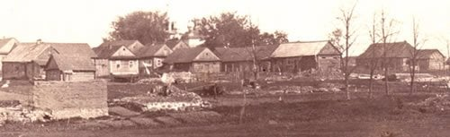
The Mir shtetl

The image of the shtetl is often synonymous with Jewish Eastern European life. Shtetl is Yiddish for “town,” and refers to the small pre-WWII towns in Eastern Europe with a significant Yiddish-speaking Jewish population. Jews occupied a large percentage of the shtetl, and were often the majority. They worked as shopkeepers, entrepreneurs, carpenters and water carriers, and Jewish life flourished. Families would live in the same shtetl for generations, forming close-knit communities.
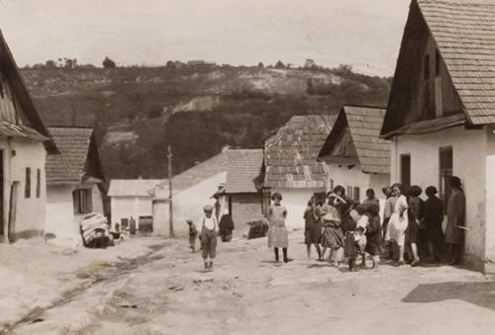
Women and children in the shtetl of Czortkow, Ukraine. (photo: Alter Kacyzne)

How the Shtetl Was Born
The beginnings of shtetl life go back hundreds of years, to before the 17th century, which saw the greatest growth of shtetls. Formed in the territories of the old Polish Commonwealth, shtetls were originally estates of the landed nobility. Jews were encouraged to settle there to boost economic growth. Many of the settlers had come from western and central Poland, which were rife with antisemitism. Even after the disintegration of the estates, the Jews remained.

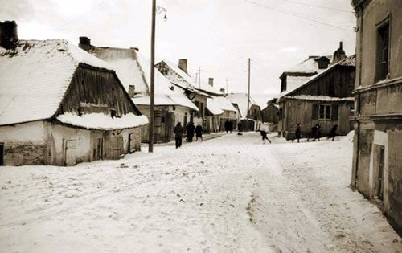
A Polish shtetl in the winter
What You’d See in a Shtetl
In addition to humble hovels, gardens and shops, the Jewish shtetl was distinguished by a number of special institutions:
Shul: The synagogue was a center of Jewish life. Men would gather in the synagogue early in the morning and late at night for prayers, a Torah class and some neighborhood chitchat.
The Cheder
In a society where even the nobility was often illiterate, Jews stood out as a people committed to educating their young. Cheder, which means “room” in Hebrew, was a one-room-school house where young boys would learn to read Hebrew and study Bible, Talmud and Jewish law.
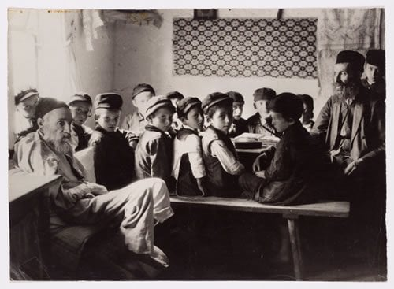
A cheder for boys in Dlugosiodlo. (photo: Alter Kacyzne)

Hekdesh: Caring for guests takes a central place in Jewish life. As such, many shtetls supported a hekdesh (Hebrew for “sacred [place]”), where wayfarers and other indigents could find lodgings when in need.
Beit Din Shtibl: Jewish life in the shtetl was regulated by Torah law. Business disputes, divorces and other legal matters would be brought to the learned men in the Beit Din Shtibl (courthouse) for resolution.

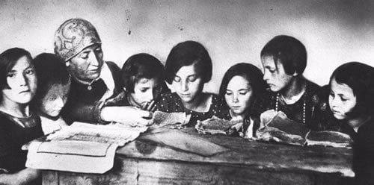
A cheder for girls in Laskarzew, Lublin. (photo: Alter Kacyzne)

Beit Midrash:
While the shul was primarily a place of prayer, a beit midrash (study hall) was a place of serious scholars, where Torah learning took place at all hours of the day and night.
[Some Jewish people lived in even smaller villages or hamlets where these amenities were often not found.]

The People You’d Meet
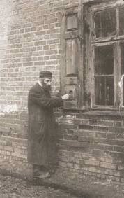
A shamash knocks on the window, reminding the residents that Shabbat is about to begin. (photo: Alter Kacyzne)
In addition to shoemakers, tanners, smiths, gardeners and peddlers, the Jewish community had its own set of functionaries:
Rabbi: Of course, there was the rabbi of the community, who would answers questions of Jewish law, support his community’s interests and provide for its spiritual well-being.
Melamed: Often destitute by the modest standards of shtetl economy, the melamed taught children Torah in the cheder.
Shamash: Tasked with running the synagogue, the shamash (warden) would make sure that the house of G-d was clean, neat and cared-for. Often, he would make his rounds in the wee hours of the morning, waking
slumbering villagers for morning services with a rap on the shutters.

The Zogerke:
Since many women in the shtetl were illiterate, the zogerke would lead them in prayer and study. Often she would read to them aloud from Tze’ena Ure’ena, a Yiddish rendition of the weekly Torah portion with a commentary based on Midrashic and other sources.
Shadchan: The family is the bedrock of Jewish life, and as such, great lengths are taken to help children find a suitable partner and marry. The shadchan would help find matches for the young men and women of a community.

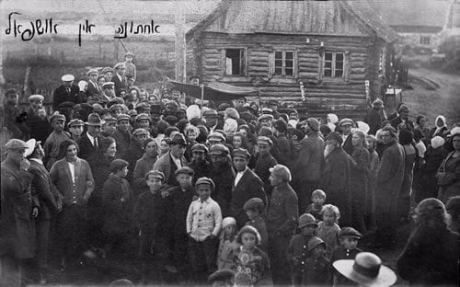
A wedding in Ushpol (Uzpaliai), Lithuania. (photo: Reuven Milon/JewishGen)
Shochet: Central to the laws of kosher is the requirement that all meat come from healthy animals that have been slaughtered in a specific manner. Families would bring their animals to the ritual slaughterer to prepare them to be eaten. The shochet was a devout and pious man.
Maggid: While the rabbi was concerned primarily with the nuts-and-bolts of Jewish law, the maggid was responsible for the moral, emotional and inspirational side of life. A powerful orator, he would seek to inspire the villagers to live honestly, kindly and piously.
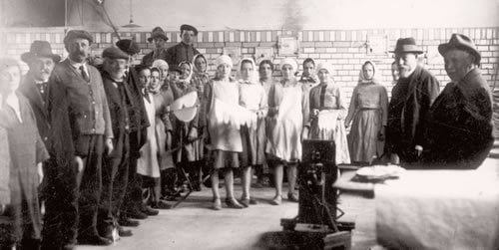
Baking matzah in the shtetl (photo: Yad Vashem)

Community Organizations
Jewish communal life was highly organized. Often, a chevra (society) would be formed to ensure that things were run in the best possible manner. Some of the common chevras that were formed in the shtetl are still existent in Jewish communities today:
Hachnasat Kallah—helped poor brides and grooms get married.
Chevra Kadisha—prepared the dead for burial.
Hachnasat Orchim—welcomed guests.
Bikur Cholim—visited and cared for the sick.
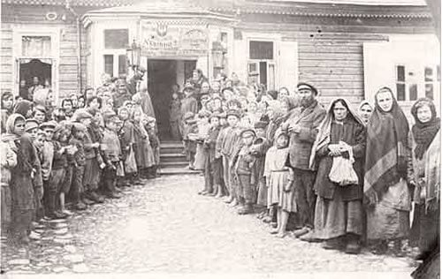
The soup kitchen in Novogrudek
There were also a number of chevras formed for the purpose of prayer or study. Chevra Tehilim would gather to say Psalms in the early morning; Chevra Mishnayot would band together to study the Mishnah, etc.
Shtetl Life
Market day would bring hundreds of wagons of peasants into town, selling goods. With the money they earned, they sometimes frequented the Jewish owned taverns and shops.
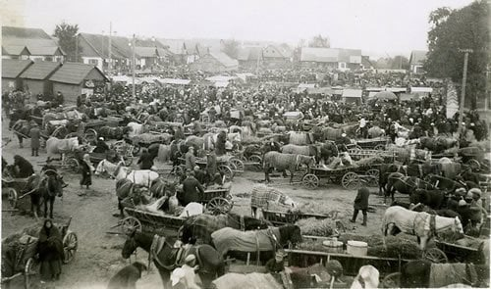
Market day at a shtetl in Poland

While the bustle of market day was an important part of shtetl life, it was not as important as the day of rest, Shabbat. Every week, Jews would spend Shabbat with their families and in the synagogue. Work would cease, and the scrimping and saving of the week would give way to meals of fish and meat.
A typical shtetl street - this one is in David Horodok, Belarus - picturing the town well/water pump

Legacy of the Shtetl
Despite a sometimes idealized vision of shtetl life, it was far from perfect. Roads were unpaved, and poverty was widespread. Pogroms, attacks by the peasant population or marauding Cossacks, devastated many shtetls across Central and Eastern Europe.
Even after shtetl life was destroyed in the Holocaust, there were some communities that rebuilt a shtetl-like existence elsewhere. Small hamlets like Kiryas Tosh outside of Montreal, and Kiryas Joel and New Square in upstate New York, were created in the decades following the Holocaust in an effort to simulate the quiet, wholesome and pious atmosphere of pre-WWII shtetl life.

Reprinted from this week’s website of Chabad.Org

